Ideation Phase
Brainstorm & Idea Prioritization Template

Date | 01 October 2025
Team ID | SWUID20250216845
Project Name | Smart Meet
Maximum Marks | 4 Marks

Brainstorm & Idea Prioritization Template:
Brainstorming provides a free and open environment that encourages everyone within a team to participate in the creative thinking process that leads to problem solving. Prioritizing volume over value, out-of-the-box ideas are welcome and built upon, and all participants are encouraged to collaborate, helping each other develop a rich number of creative solutions.
Use this template in your own brainstorming sessions so your team can unleash their imagination and start shaping concepts even if you're not sitting in the same room.
Step-1: Team Gathering, Collaboration and Select the Problem Statement

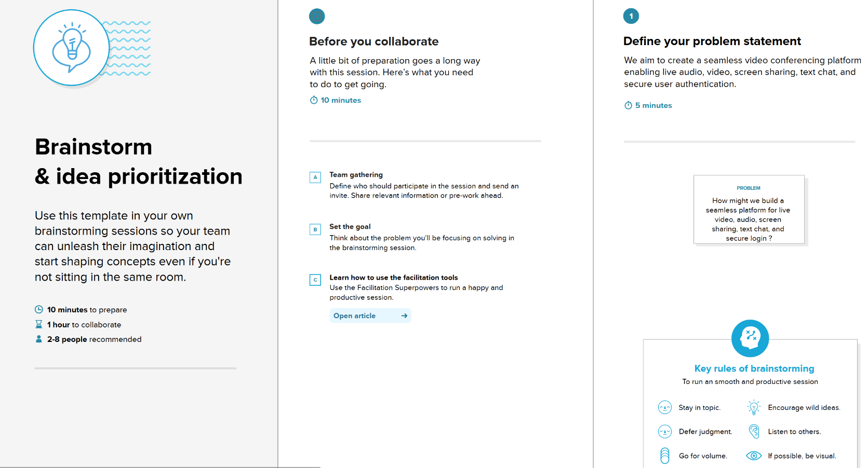

Step-2: Brainstorm, Idea Listing and Grouping
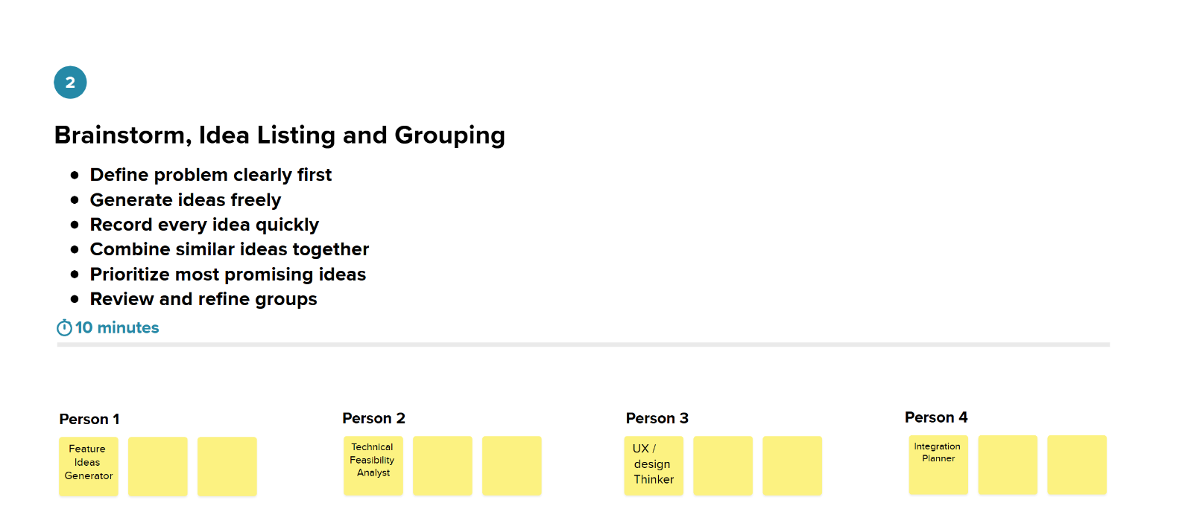

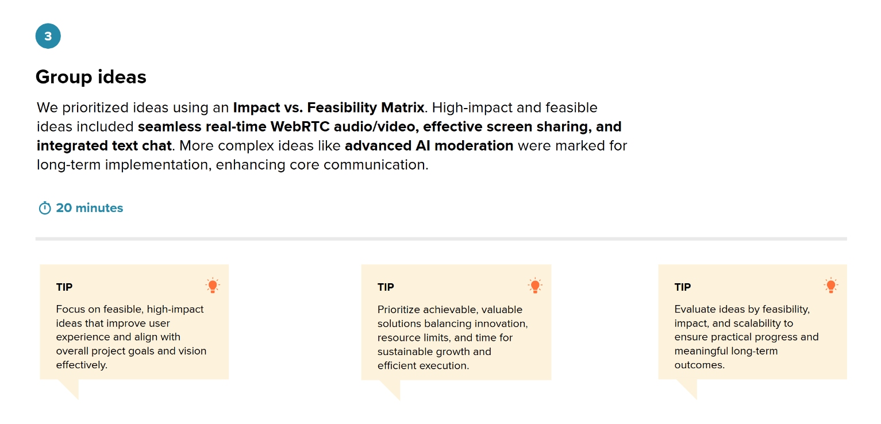

Step-3: Idea Prioritization

